Description on how to download Intraday FX data from Alpha Vantage:

Alpha Vantage provides APIs to fetch time series data for stocks as well as physical and digital/crypto currencies. FX data include intraday data with time intervals 1min, 5min, 15min, 30min and 60min.

Users will need to get an API key from Alpha Vantage (https://www.alphavantage.co/) first. Unfortunately the free API key only allows making 5 requests / minute (https://www.alphavantage.co/support/#api-key). If you need to make more frequent requests, please upgrade your API key (https://www.alphavantage.co/premium/).

Please also refer to the “Alpha Vantage API Documentation” to understand what and how data can be downloaded. One key point to note: By default, outputsize=compact. Strings compact and full are accepted with the following specifications: compact returns only the latest 100 data points; full returns the full-length time series of around 5 days. The "full" option is recommended for intraday data download.

Set-up:

- Copy the following line and append to your existing “mywebserver.txt. If your portfolio name is “currencies_5m.tic’, change <your-portfolio-name> to currencies_5m. The interval parameter also needs to be changed to match the interval for this portfolio.

<your-portfolio-name>, https://www.alphavantage.co/query?function=FX_INTRADAY&from_symbol=SSSS&interval=5min&outputsize=full&datatype=csv&apikey=<your-personal-API-key>,I1,alphavantage_I1(csv).fmt

- Copy the supplied “alphavantage_FX_I1(csv).fmt” file to the “fmt” subfolder under the Data File Location (indicated on the Preference screen). If you own an upgrade API key, the myFetchDelay parameter in this file may be set to 0.

- Copy the supplied “alias_alphavantage_FX.csv” file to the Program Installation folder. You may need to add more entries for your FX pairs.

- Run HSQuote Plus and use the same ticker symbols as on Yahoo Finance, such as EURUSD. Note that the HSQuote convention of EURUSD=X may be used as well.

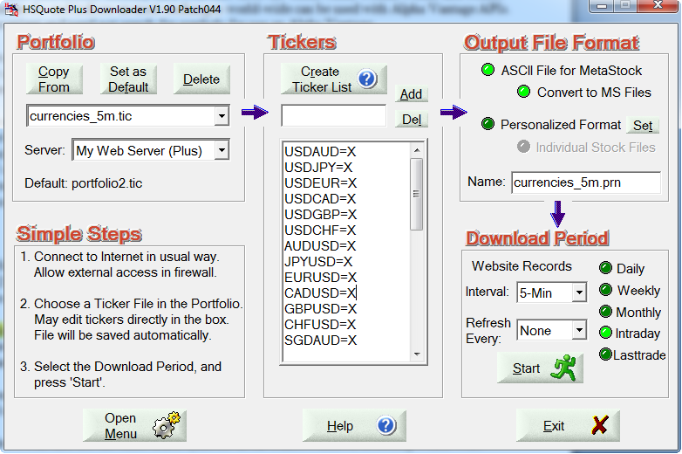

Backfilled Intraday Data Download:

For the first time download, you may click on the “Daily” option, and change the Fr. Date to about 10 days back, and then switch back to the “Intraday” option. This will allow capturing a few days of backfilled intraday data from Alpha Vantage.

HSQuote program will keep track of the last successful data date. You don’t need to indicate the starting period of the date range. Just leave the Intraday option selection, and click the Start button to download data.

